1. **Install git.**

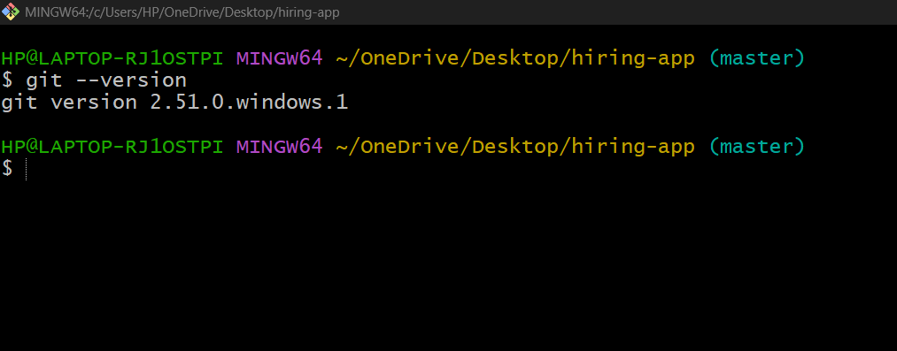

1. **Create a repo in github with README.md and .ignore file.**

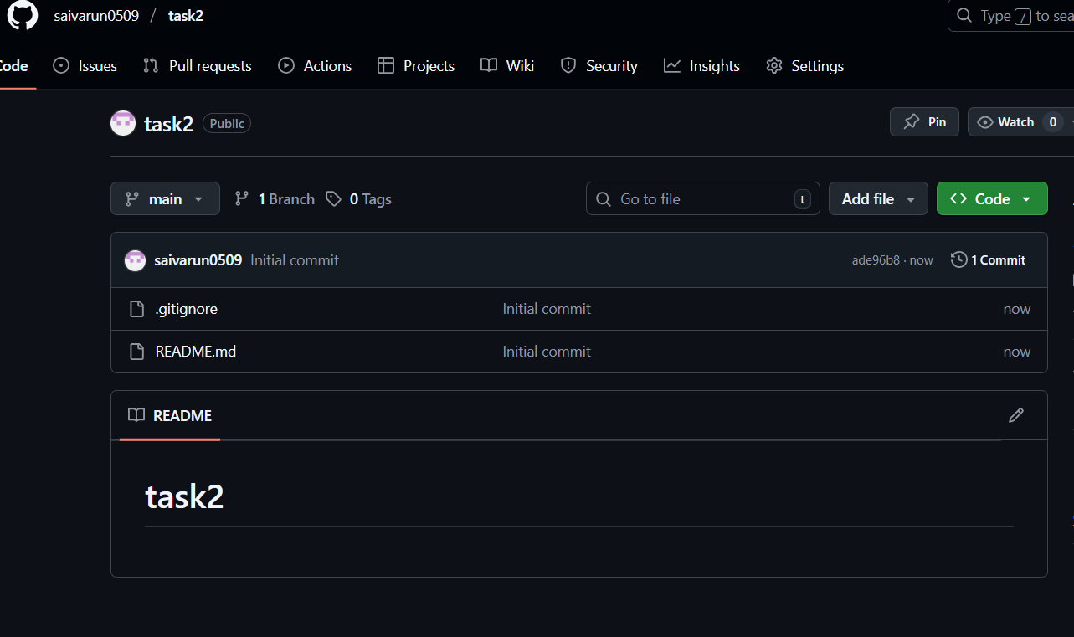

* Select new repository.
* Give a name to the repository. [task2]
* Turn on Add README option.
* Add .gitignore.

1. **Clone the created repo to local.**

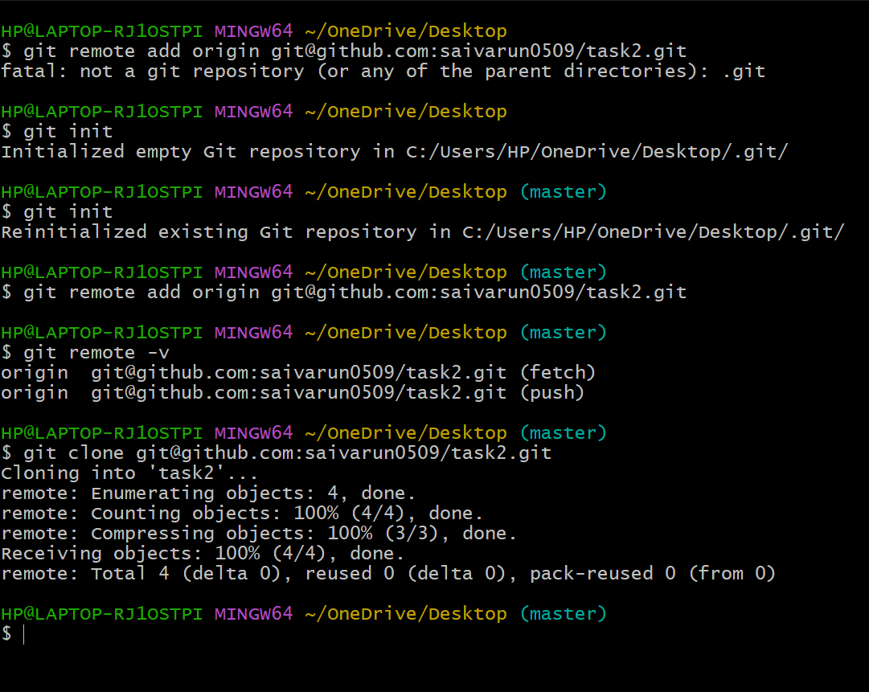

* Copy the ssh url of repository.
* git remote add origin + ”SSH URL” [To add github to our local git]
* git remote -v [To check for added address]
* git clone+ssh url [To clone]

1. **Create two files in local repo.**

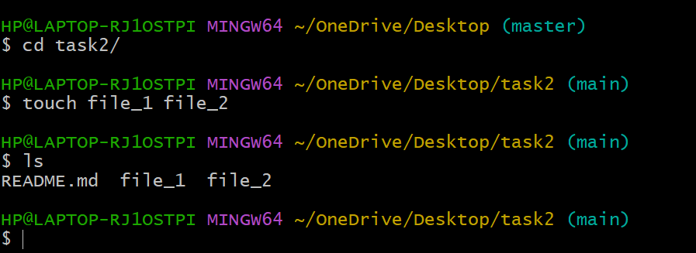

* Use touch command and created two files file_1,file_2.
* ls to list the files.

1. **Commit two files and push to central Repository.**

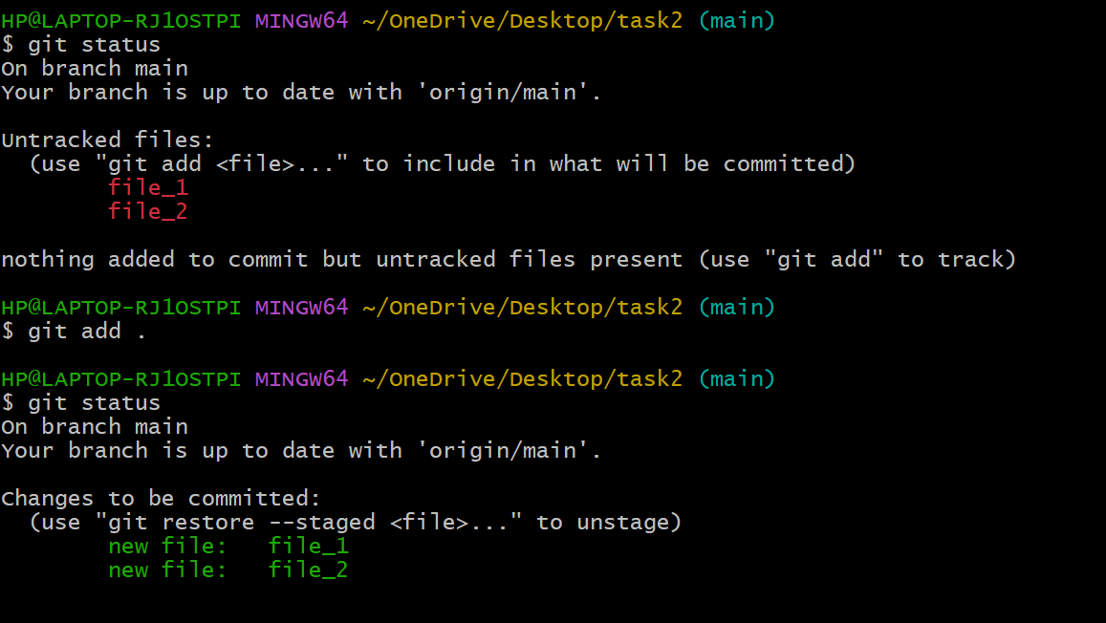

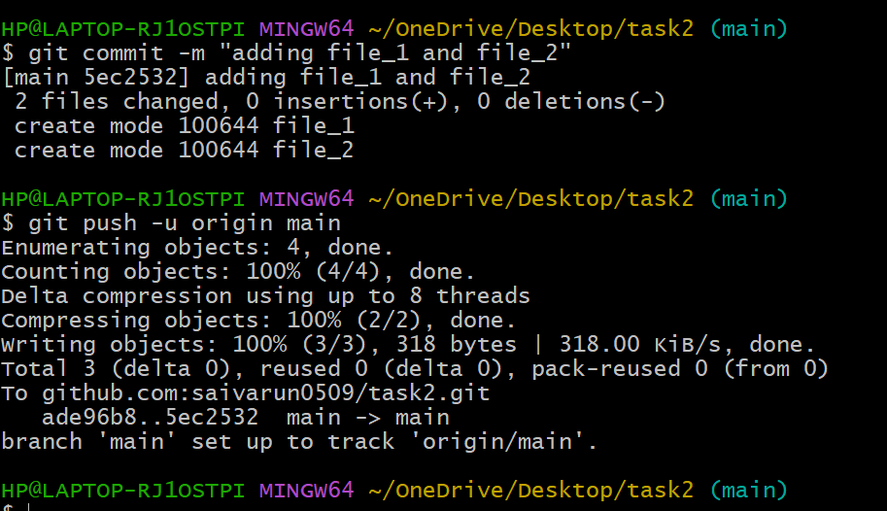

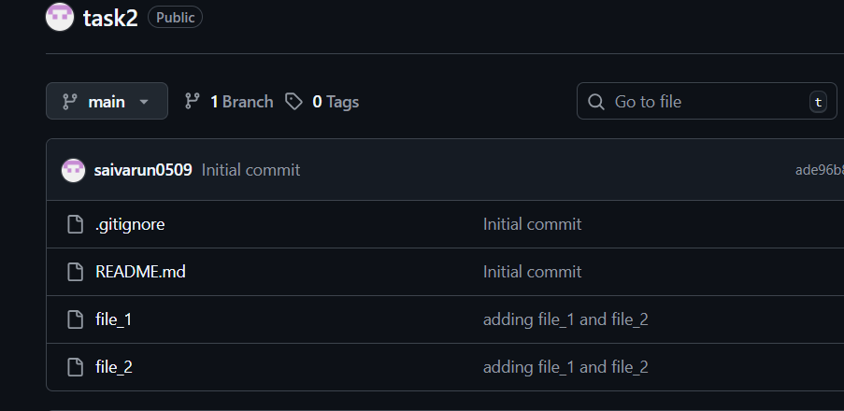

* git status [To know the status]
* git add . [To add all files from untracking to tracking area]
* git commit -m “MESSAGE” [To commit files]
* git push -u origin main [To push from local to central]

1. **Create a branch in local and create a sample file and push to central.**

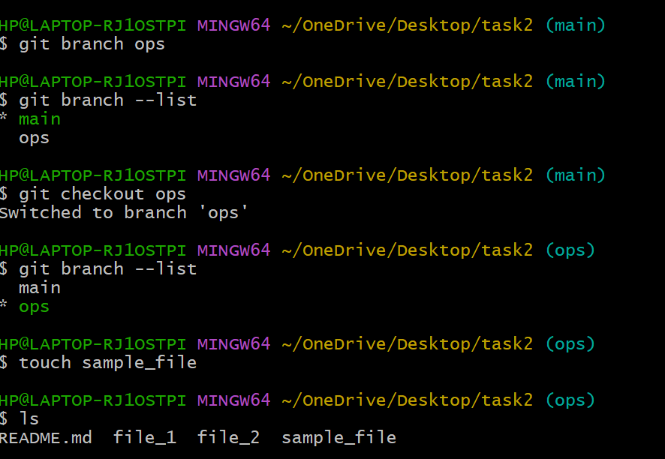

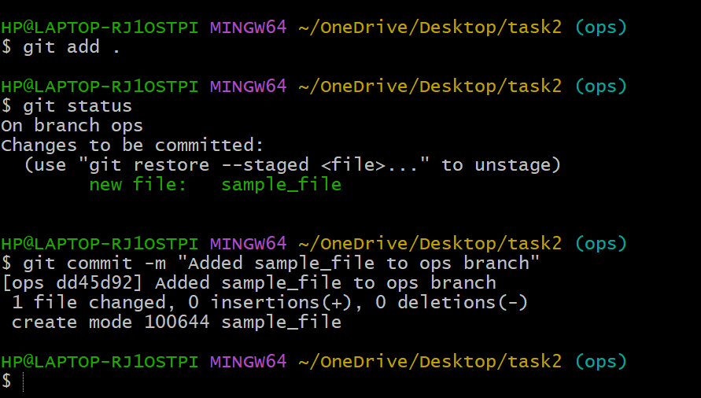

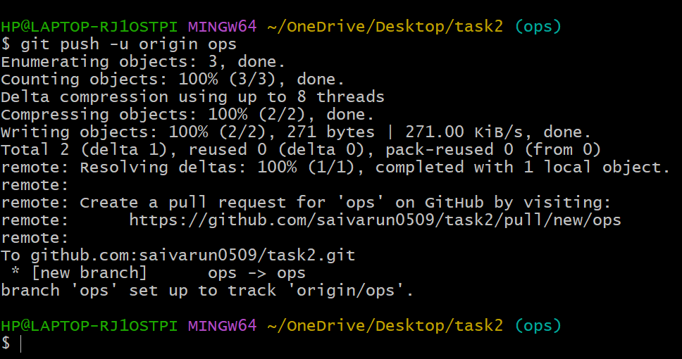

* git branch “ops” [To create a branch name ops]
* git checkout “ops” [To switch from one branch to other]
* touch ”z” [It created a file z inside the branch]
* git add . [To move from untracking to tracking]
* git commit -m “MESSAGE” [To commit all files]
* git push -u origin “ops” [To push file from local to central]

1. **Create a branch in github and clone that to local.**

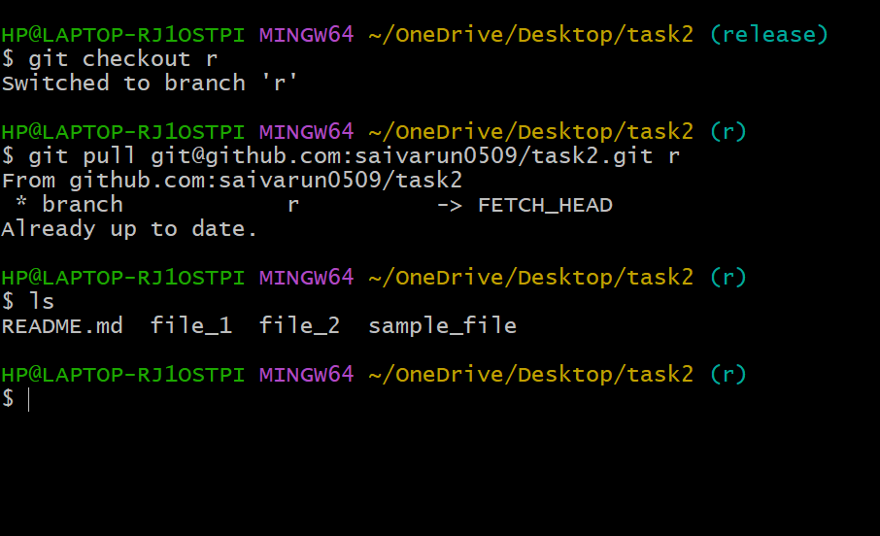

* In the github account on the left side select main section and then enter a branch name ”r” and create.
* In local create a new branch of same name and switch to new branch.
* git pull “URL” to pull files from github.

1. **Merge the created branch with master in git local.**

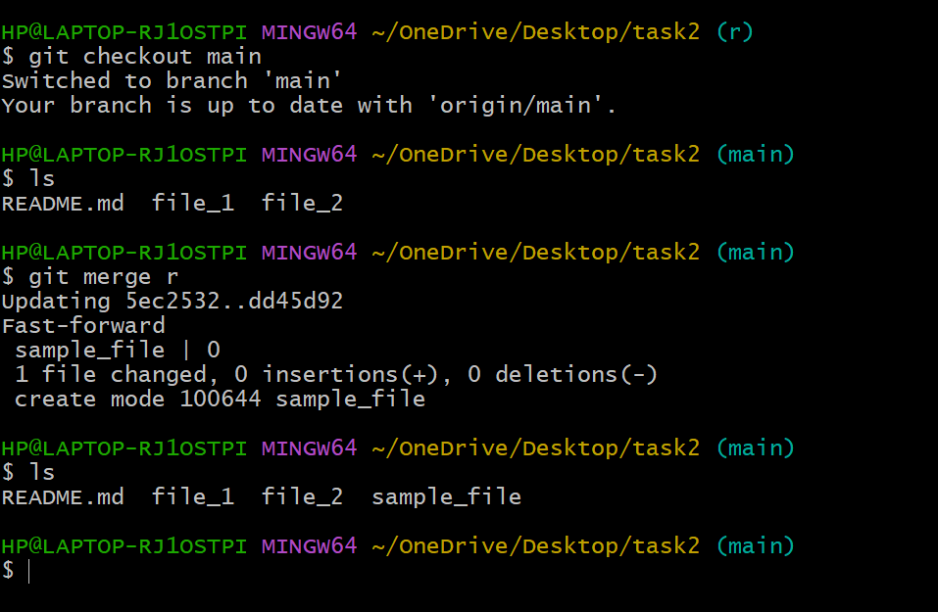

* Git merge to merge.

1. **Merge the created branch with master in github by sending a pull request.**

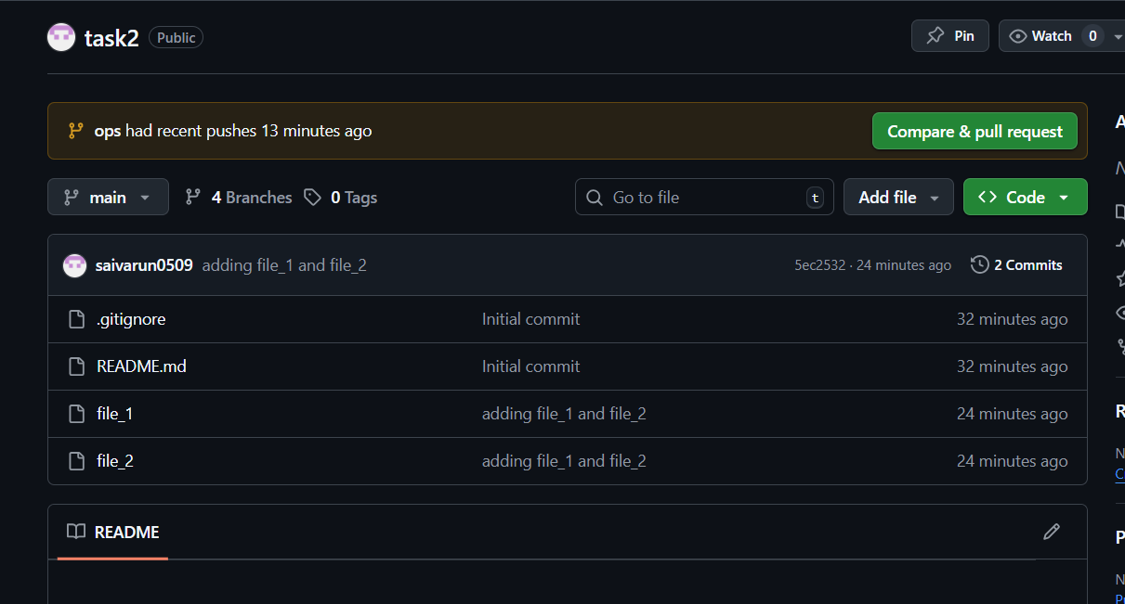

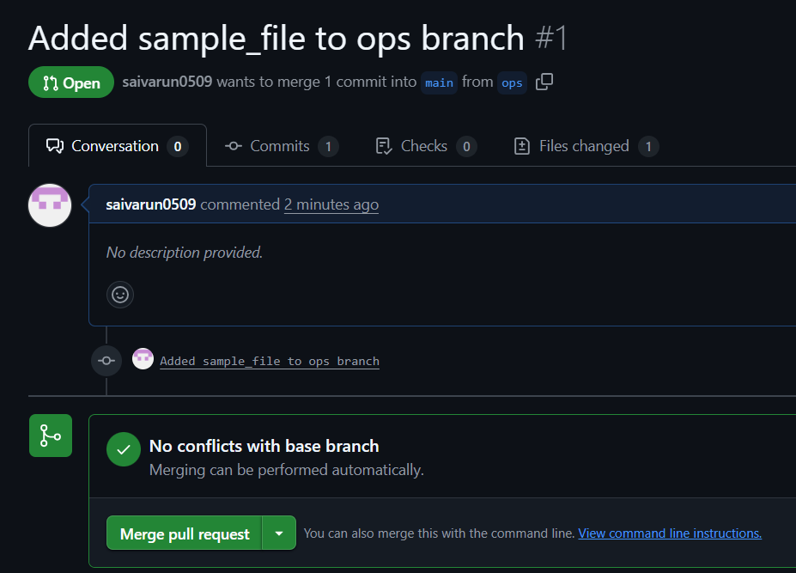

* Select compare and pull request.
* Add title and reviewer if needed and select create pull request.
* Select merge pull request
* Git commit message and select confirm merge
* Pull request will be successfully executed and will be merged.

1. **Create a file in local and send that to branch in github.**

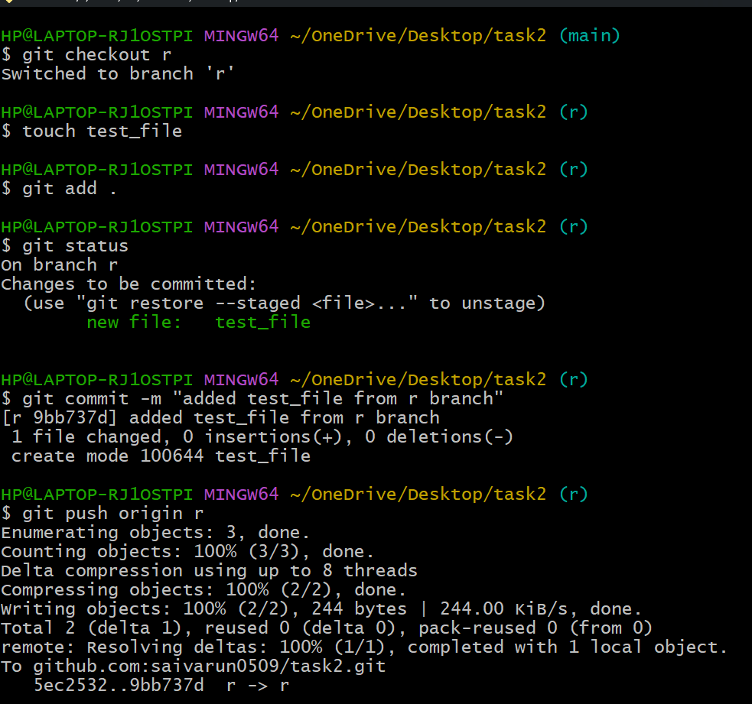

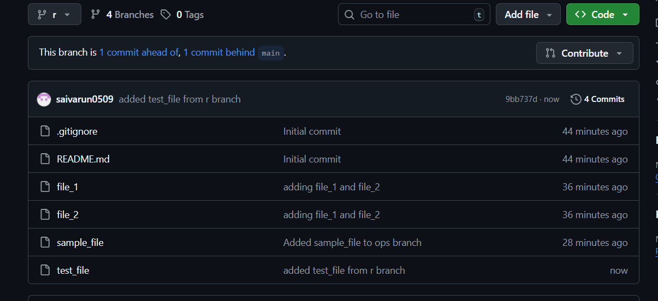

* Use touch test_file
* Git add .
* Git commit -m “Add test_file from Devops branch”
* Git push origin Devops.

1. **Clone only a branch from github to local.**

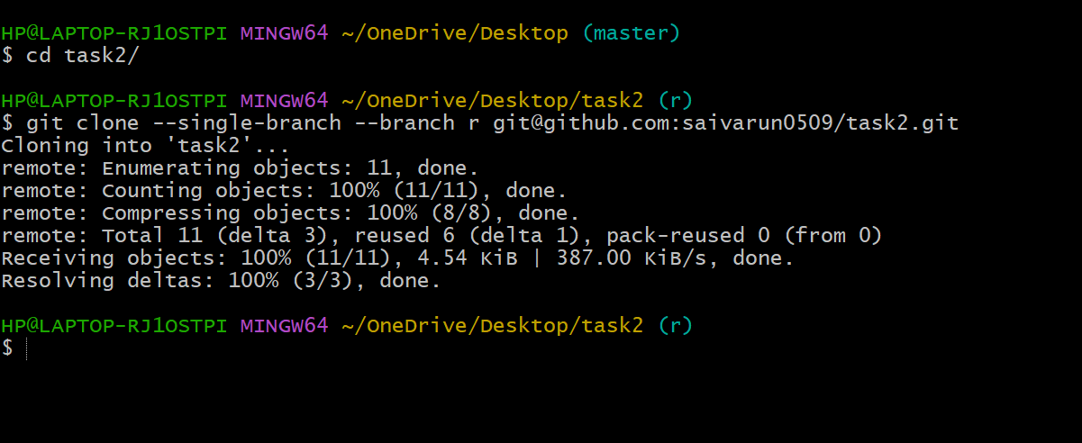

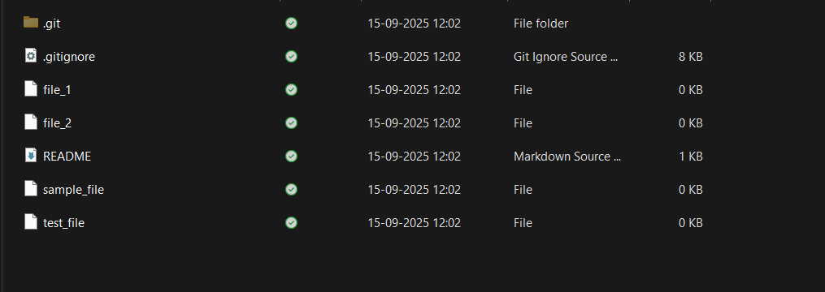

* Use git clone –single branch –branch “branch_name” “URL”.
* To clone only 1 branch from github.

1. **Create a file with all passwords and make that untrackable with git.**

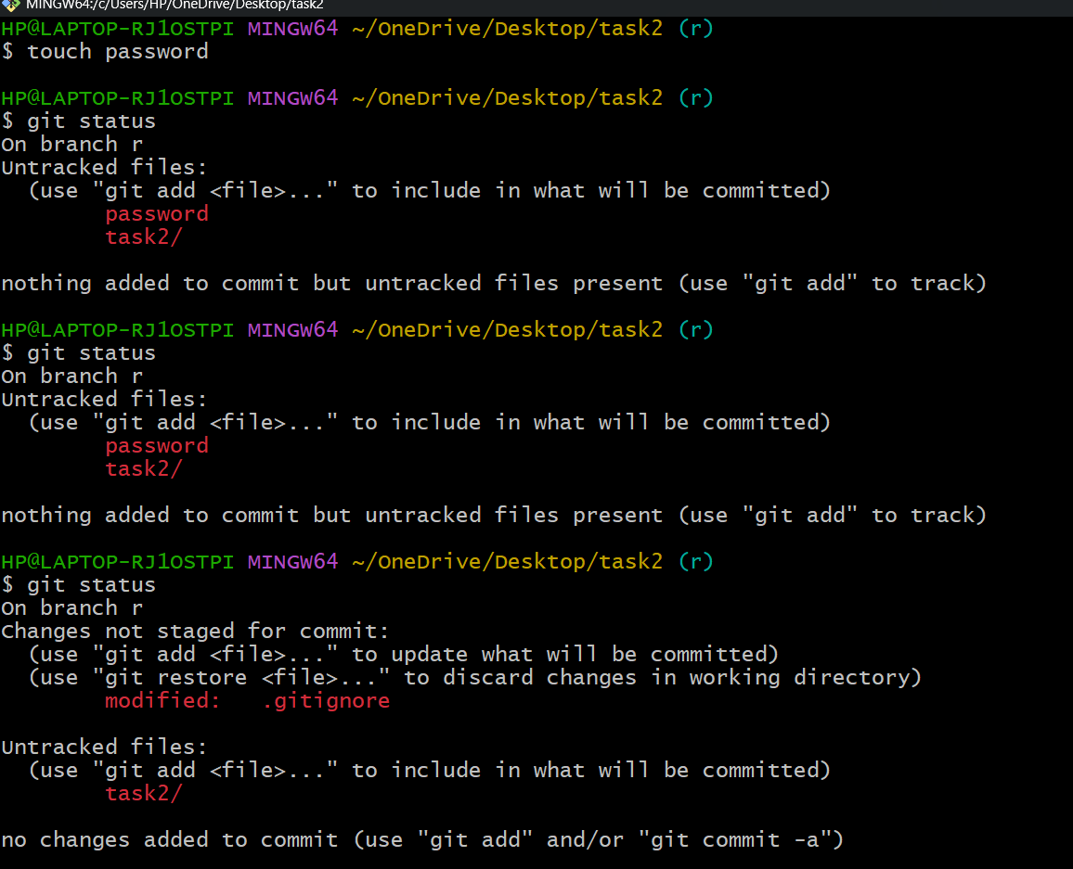

* Create a file containing password and check status.
* Use vs code and add the password file in .gitignore.

1. **Make a commit and make that commit reset without savings changes.**

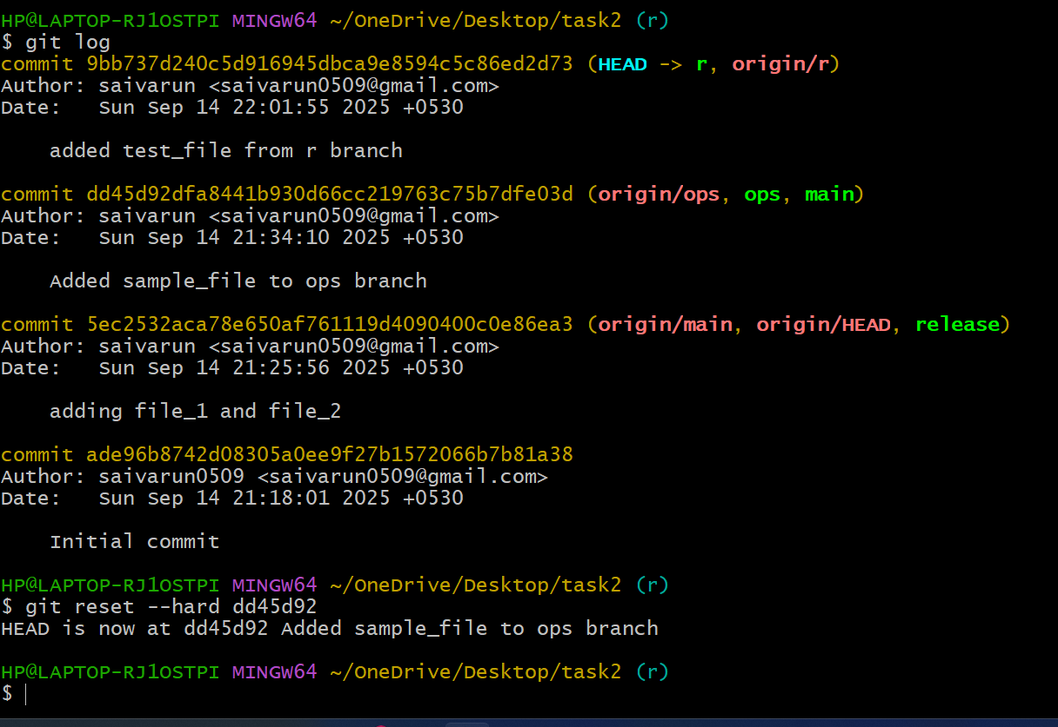

* **Use git reset –hard commit_id**

1. **Revert a commited commit to the older version.**

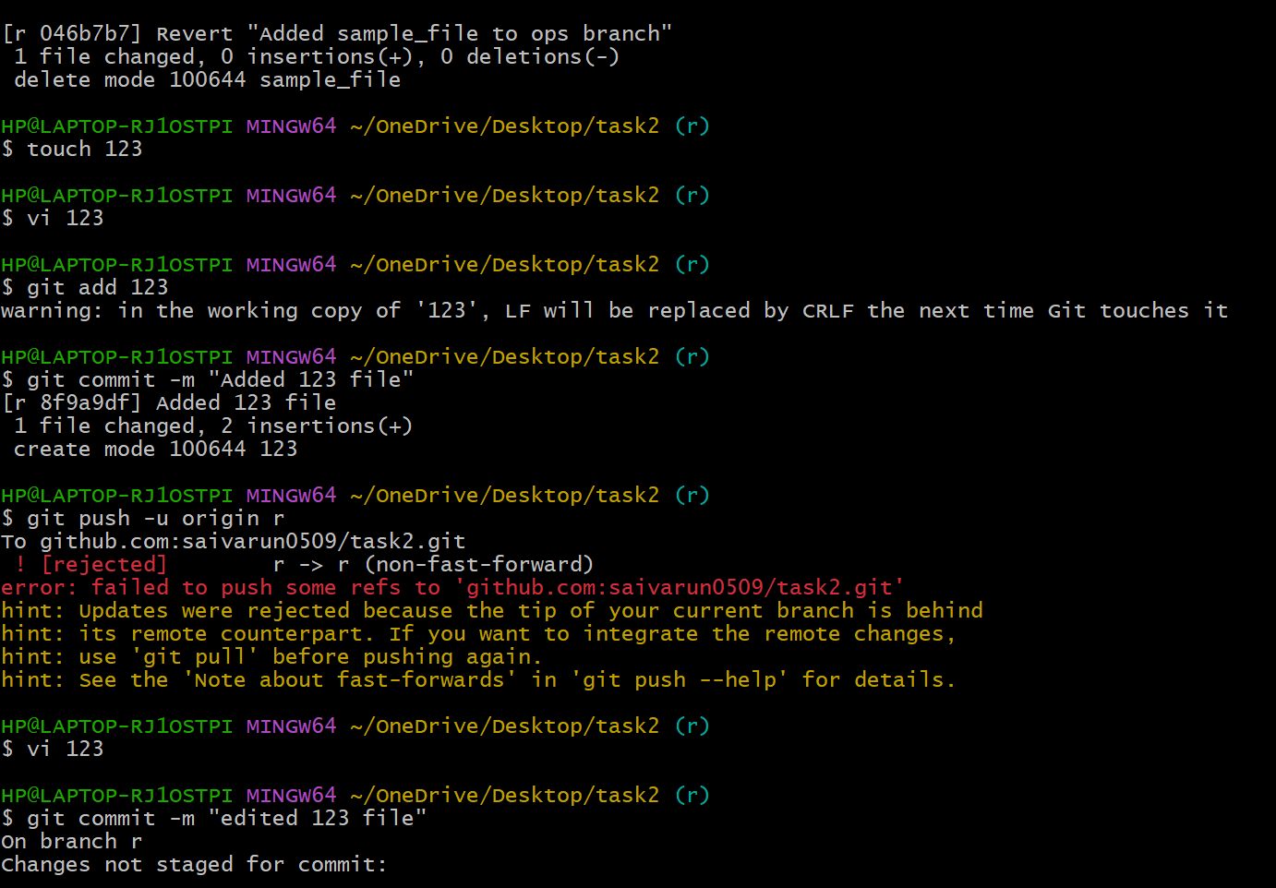

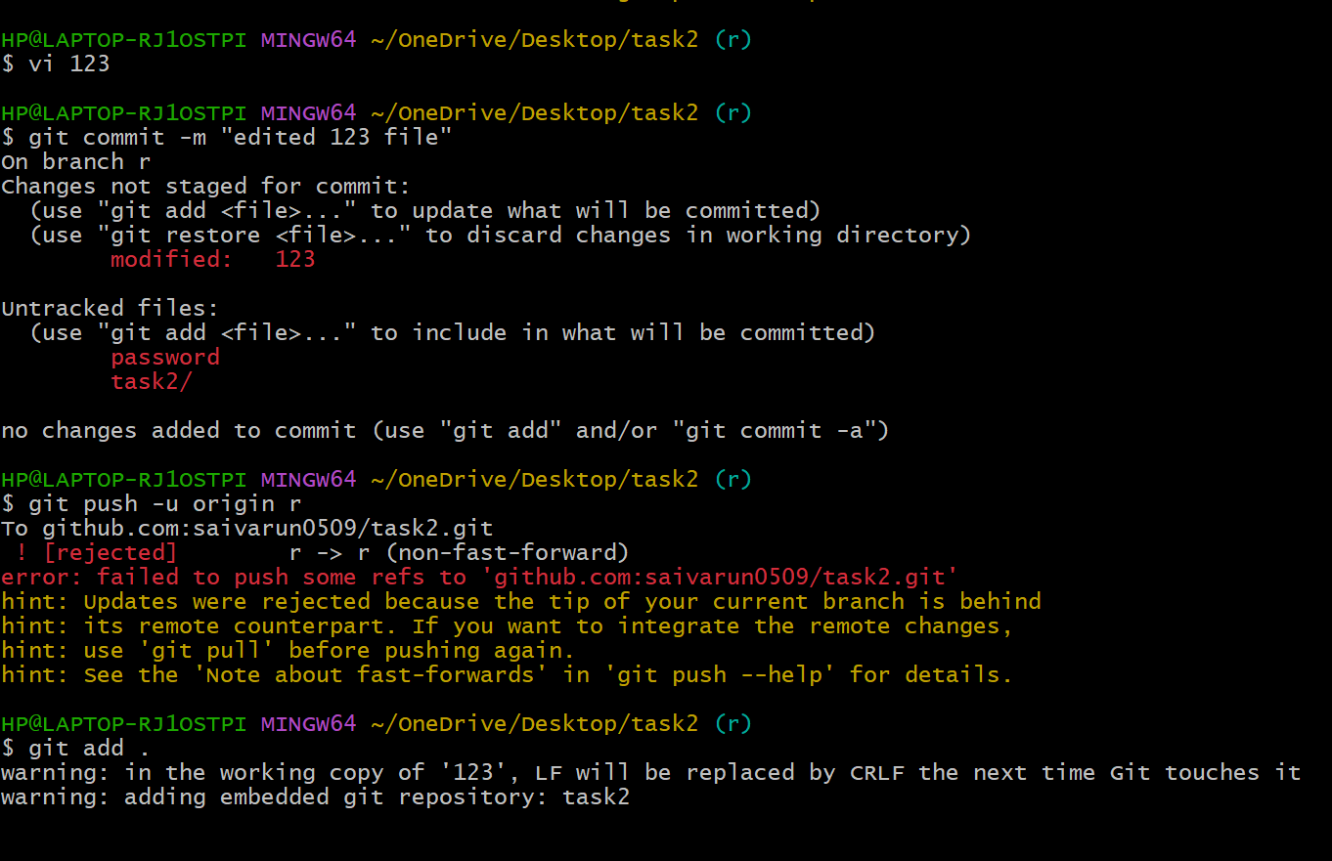

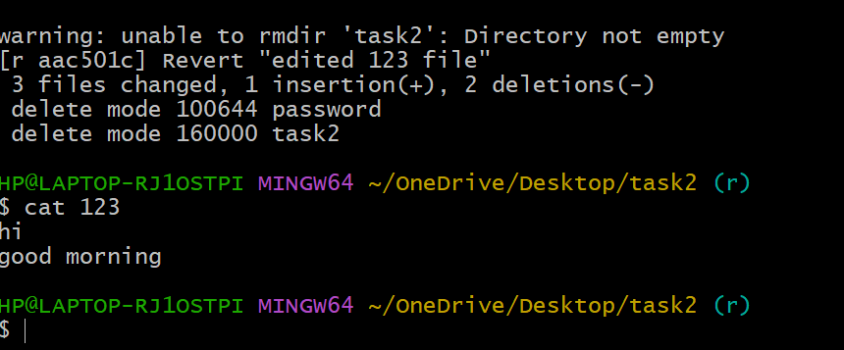

* Use git revert “commid_id” to revert a commited commit to older version.

1. **Push a file to stash without savings the changes and work on another file.**

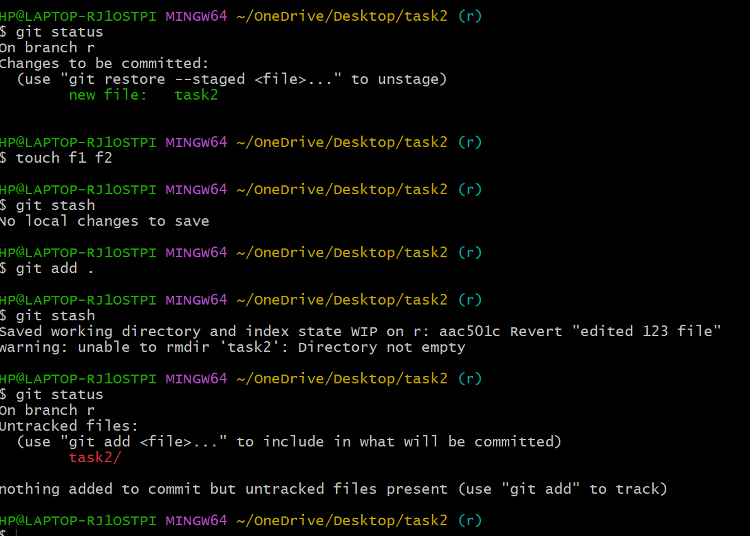

* Use git stash to push file to stash.

1. **Undo the stash file and start working on that again.**

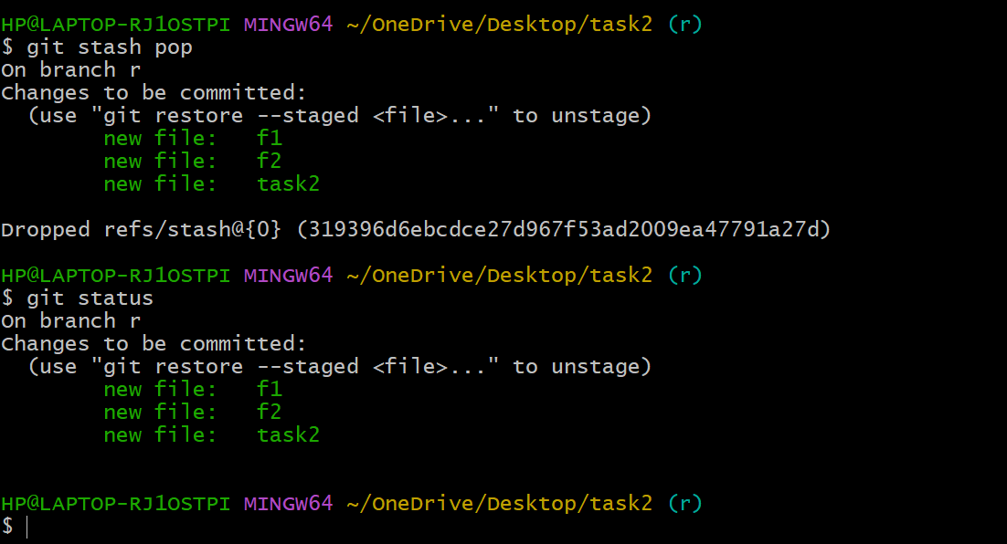

* Use git stash pop to undo the stash.

1. **Generate a ssh-keygen and configure into github.**

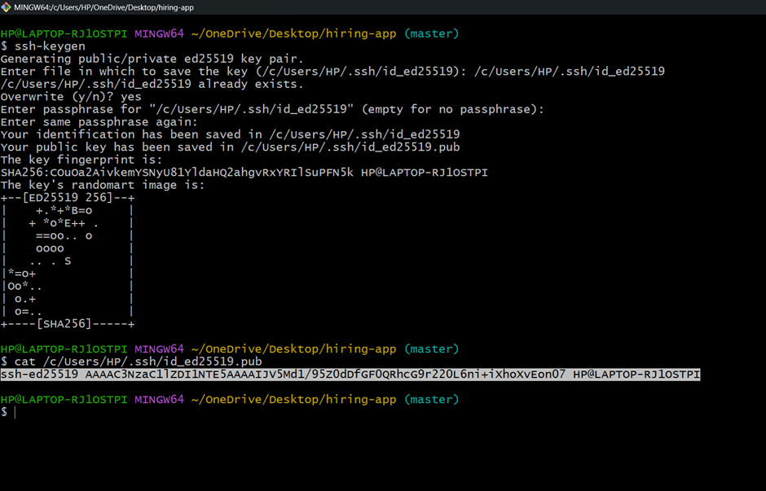

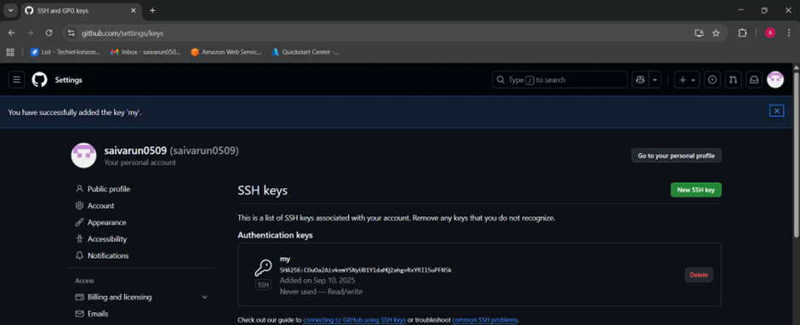

* **Use ssh-keygen to generate keygen and use cat/path/to/key to display key.**

1. **Configure webhooks to github.**

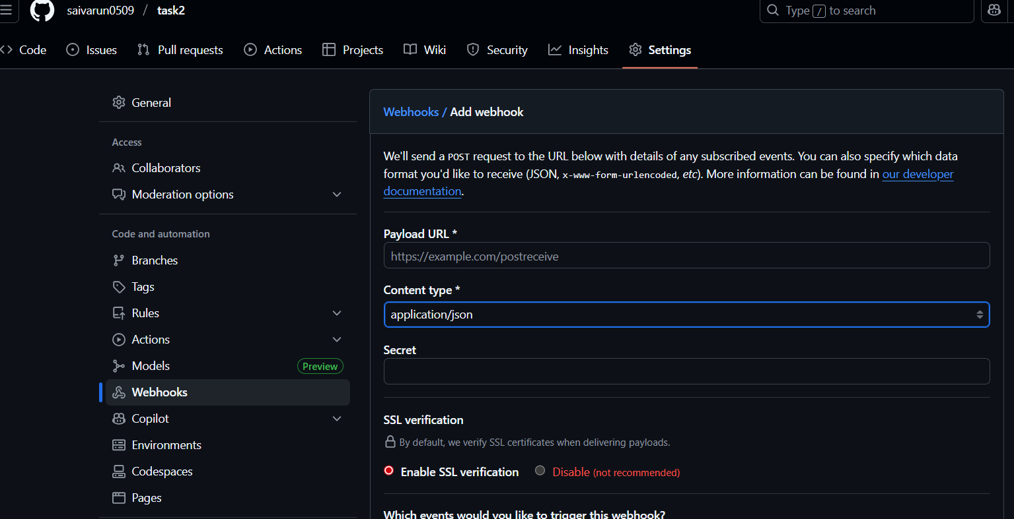

1. **Basic understanding of .git file.**

* It is a hidden folder automatically created when initializing a repo using git init.
* It stores all the metadata ,history ,configuration.
* Without this directory, a folder will not be recognized as a git repository and cannot benfit from version control features.

1. **Check all the logs of git.**

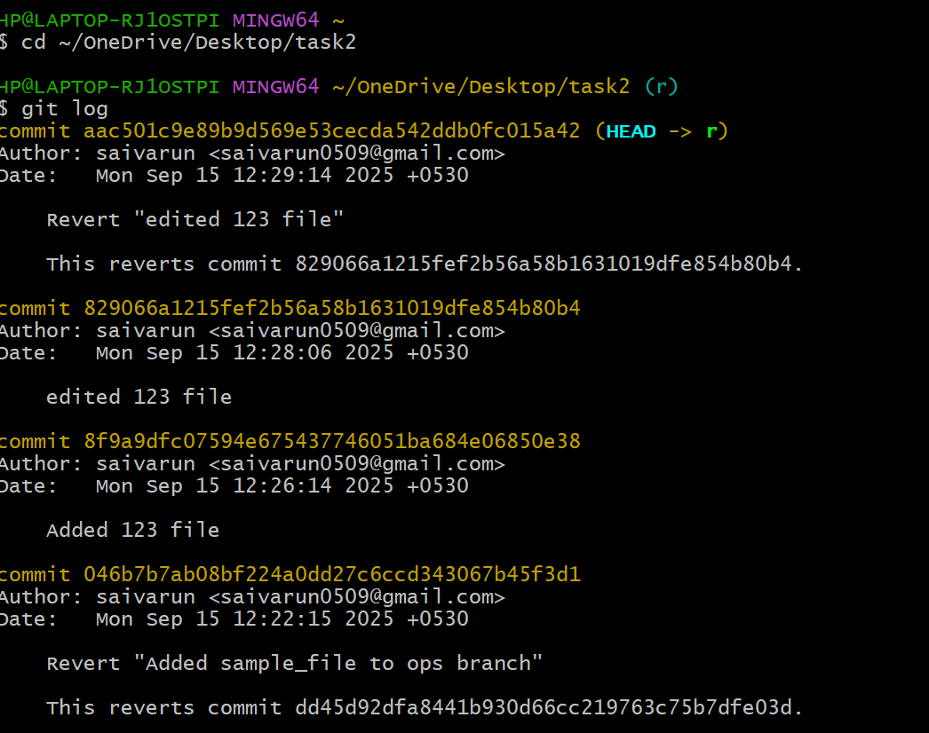

* Use git log to check all the logs.

1. **Rename the commit message.**

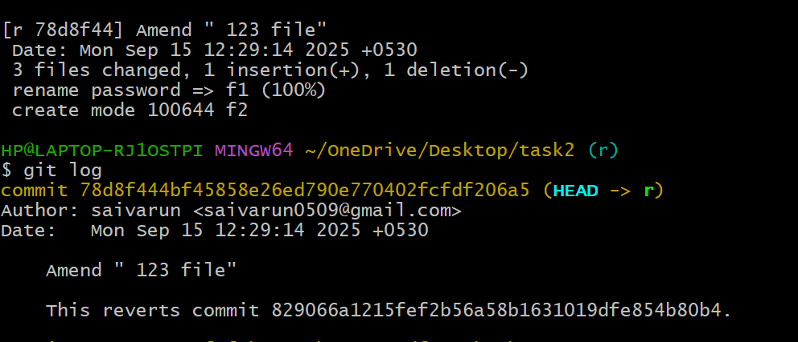

* Use git commit –amend to rename the commit message.

1. **Merge multiple commits into single commit.**

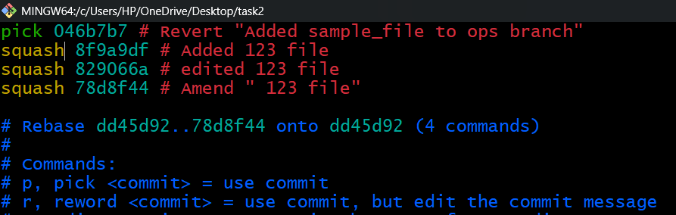

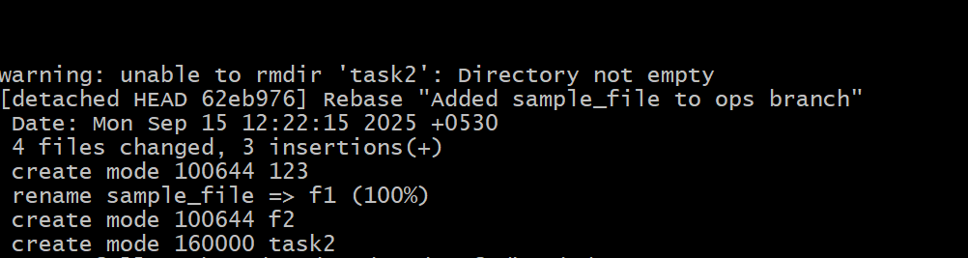

* Use git rebase -I head~4 and replace pick with squash